/ SPANISH TAX GUIDE

/ 2025




Table of contents

Who pays taxes in Spain? 3
Taxation for Residents 4
Taxation for Non-Residents 5
Dual Taxation Agreements 6
Income Tax 6
Registering To Pay Taxes 7
Filing Your Tax Return as a Resident 8
Filing Your Tax Return as a Non-Resident 9
Income Tax for Foreigners Working on Assignment 10
Tax Deductions and Allowances 11-12
Marriage and Taxes 12
Property Tax 13
Capital Gains Tax 14
Spanish Wealth Tax 14
Inheritance and Gift Tax 15
VAT (IVA) 15
Corporate Tax 16
Rental Tax 16-17
How to proceed?........................................................................................................................................18

Who pays taxes in Spain?

Those who live and work in Spain will pay taxes on both income and assets. To do so, they will be required to file a tax return. However, whether you pay taxes on all your assets or just those owned in Spain will depend on your residency status.

Spanish tax includes property, investment interest, and goods and services offered.
The tax year in Spain starts at the beginning of the calendar year and ends on the last day of the calendar year. Residents are those that live in Spain more than 183 days per years.
As a resident, you will pay Spanish income tax on income earned anywhere in the world. Taxes are calculated on a progressive scale, though deductions are available. Non-residents will only pay tax on Spanish income plus potential income you could make if you rent your Spanish property. This tax is paid even if you choose not to rent.
Taxes are divided between state and regional governments.
Each region elects its own tax rates, so rates vary across the country for:
- Income tax
- Property tax
- Wealth tax
- Capital gains tax
- Inheritance tax

Taxation for Residents

You are considered a resident for fiscal purposes if you live in Spain more than 183 days. This does not have to be consecutive days. You are also considered a resident if your main vital interests are in Spain such as family or business.
As a resident, you will need to prepare a Spanish tax return if:
- Employment income is more than EUR 22,000 except if the income is a pension from one’s country of origin or a company salary outside of Spain.
- You are self-employed
- You have your own business
- Rental income is more than EURO 1,000 during the year
- Capital gains plus savings income of more than EUR 1,600 a year
- This is your first year declaring tax residency Using Form 720, you have to declare international assets worth more than EUR 50,000.
Then, you will be taxed on income after the following deductions: Social security deductions • Pension • Personal allowance
- Professional costs • And more the more you make, the higher the tax rate is going to be.
Contact us about Spanish resident taxes

Taxation for Non-Residents

For those living in Spain less than 183 days, you will pay taxes as a non-resident. This means that taxable income is only that earned while in Spain. You will have a flat rate and no deductions.
Property owners in Spain must submit a tax return and pay Spanish property taxes plus local property taxes even if the property was not rented.
The tax rate for non-residents in Spain is 19% for EU residents, Iceland and Norway, 24% for all other countries.
Please contact us about Spanish non-resident taxes.

Dual Taxation Agreements

Spain has many agreements with other countries to help residents avoid double taxation.
You can find a list of current treaties at the Spanish tax authority.

Income Tax

Personal income tax is known as IRPF. Each region in Spain determines the rates, so your tax will depend on where you live. Currently, Madrid has the lowest rates from 19% to 43.5%. Andalucia has the highest top rate at 48% for income of more than EUR 120,000.
Here are the basic Spanish tax rates. You will note that the government is working to reduce and simplify taxes in Spain:
•Up to EUR 12,450: 19 percent
•EUR 12,450–20,200: 24 percent
•EUR 20,200–35,200: 30 percent
•EUR 35,200–60,000: 37 percent
•EUR 60,000-300.000: 45 percent
•More than EUR 300.000: 47 percent (It can vary depending on the autonomous community)

Keep in mind that your taxes will include the state’s general tax rates plus regional rates.
To see regional Spanish tax rates, click here.

Registering To Pay Taxes

In order to pay Spanish taxes, you will need to register with the Spanish tax authority. This is true whether you are a resident or non-resident.
You will need your NIE number and should fill out Form 030. This form is also used to change your details.
To learn more about filling out Form 030, click here.

Filing Your Tax Return as a Resident

If you are a resident in Spain for the first time, then you are required to file a tax return. In subsequent years, you only file a tax return if:

- Your income from all sources is more than EUR 8,000, AND you have less than EUR 1,600 in bank interest or investment income.
- Your rental income is more than EUR 1,000
- Pensions: Taxed progressively from 8 to 40%
- Your annual income from employment is more than €22,000.

To file, you will use Form 100. Tax returns are submitted during May and June, with June 30th as the deadline.

Filing Your Tax Return as a Non-Resident

The current income tax for non-residents is 24% unless you are an EU/EEA citizen with a 19% rate.

Additionally, here is how income is taxed in the following income categories:
  - Capital gains from transferred assets: 19%
  - Investment interest and dividends: 19%. EU citizens are exempt. (This rate may be lower due to double taxation treaties.)
  - Royalties: 24%

Income Tax for Foreigners Working on Assignment

If you are working in Spain because of an employment contract with a Spanish company, you will be subject to Beckham’s Law.
In this situation, you only taxed on Spanish income, even if you live in Spain more than 183 days.
The rate is 24% up to EUR 600,000 and 45% for more than EUR 600,000.
Additionally, capital gains tax on interest outside of Spain is excluded.
You may fall under Beckham’s Law as a Spanish tax resident if you have not lived in the country in the past ten years. You must declare this status within six months of your arrival and keep this status for up to five years.

Tax Deductions and Allowances

As a resident, you will be given some tax deductions and allowances.
These include:
  - Personal allowance under age 65: EUR 5,550
  - Personal allowance age 65 to 74: EUR 6,700
  - Personal allowance 75 and older: EUR 8,100
Allowances for children under the age of 25 who do not earn more than EUR 8,000:
    - EUR 2,400 for the first child
    - EUR 2,700 for the second
    - EUR 4,000 for the third
    - EUR 4,500 for the fourth
An additional allowance of EUR 2,800 for each child under three years.
  - Allowances for having a senior living with you making less than EUR 8,000:
    - EUR 1,150 for seniors 65 to 74
    - EUR 2,550 for seniors 75 and up
  - Social security deductions
  - Pension contribution deductions
  - EURO 1,500 of dividend interest deduction

  - Home buying deductions (only if the home was purchased before January 1, 2013)
  - Home renovating deductions (only under approved regional or national programs)
  - Charitable donations deductions (percentage depends on amount
and frequency

Marriage and Taxes

When married, you can choose your tax status as single or married. Compare your tax rate to determine which would be most beneficial to you.
Keep in mind that there is an additional married couple’s allowance of EUR 3,400 in addition to the personal exemption of EUR 5,550.

Property Tax

If you own property at the beginning of the calendar year, you will need to pay a local property tax known as IBI.
This is true of both residents and non-residents.
The amount is the rental value times the tax rate. These tax rates vary by municipality.
You will also pay the rubbish collection tax. For non-residents, you will also pay an imputed income tax. This is a flat rate on the income potential of your property. If you sell a property, you will pay:
  - Property transfer tax (ITP)
  - Local tax on the increase in value of the land

Capital Gains Tax

In Spain, capital gains are paid on the profits from selling a property or other investment. These rates have recently been cut. (This indicates that this is if you sell while being a tax resident in Spain.)
  - 19%: Profit up to EUR 6,000
  - 21%: Profits from EUR 6,000 to EUR 50,000
  - 23%: Profits above EUR 50,000
  - 27%: Profits above EUR 200,000

Spanish Wealth Tax

Spanish citizens want the wealth tax abolished, but the wealth tax is currently in force and is payable on the value of your assets at the end of each year.
This tax is for net assets of more than EUR 700,000 at a rate of 0.2 to 2.5%.
As with income taxes, residents pay on all assets, and non- residents only pay on Spanish assets.

Inheritance and Gift Tax
Inheritance and gift taxes, sometimes known as succession taxes, have changed for EU/EEA citizens.
Those from the EU/EEA will be treated as residents for this tax, effectively reducing it from 80% to 1 to 7%, depending on the region.
If you have paid an inheritance or gift tax between 2011 and 2015, you may be due a refund.
Some regions, like Andalucia, have created inheritance laws that favor families, reducing inheritance taxes significantly.
Since Spanish taxes are complex, be sure to speak with an expert.

VAT (IVA)

VAT stands for value-added tax. It is sometimes known as IVA in Spain (Impuesto sobre el Valor Añadido):
  - IVA General: 21% on goods and services – 21 percent on goods and services.
  - IVA Reducido: 10% on passenger transport, toll roads, amateur sporting events, exhibitions, health products, non-basic foods, rubbish collection, pest control, and wastewater treatment.
  - IVA Super reducido: 4% on essential foods, medicine, books, and newspaper
As of July 2017, the tax authority now requires freelancers to
submit invoices online to their website. Vat payers will be given 8 days to do so.

Corporate Tax

Corporate taxes, like personal taxes, have been reduced recently in Spain. Here is a general overview of corporate taxes:
  - General corporate tax rate: 25%
  - New company tax rate: 15% for first two years
  - Profits locked into a special reserve for five years: Reduction of tax by 10%
  - The same principles apply to net profit earned from rental properties, when the landlord is a Spanish company, Profits are taxed at the standard corporate tax rate of 25%, unless the company is a startup, in which case a reduced rate of 15% applies to taxable profits for the first two years of operation.
If you need information on self-employment and freelancers in Spain, click here.

Rental Tax

Tax resident in Spain:
You are required to declare any earnings from rental properties on your annual declaration of income tax (IRPF or the Impuesto de Renta de Personas Físicas, in Spanish) as a landlord or private
individual and tax resident in Spain.
The amount of tax you pay will depend on the total amount you earn during a fiscal year. This said, a few deductions can be offset against gross income earned from rent.
Some examples of the relevant deductions could be;
- Maintenance costs
- Annual depreciation
- Mortgage interest
- Community charges, municipal
- Property taxes
- Refuse collection and similar outgoings.

Furthermore, when a property is rented to tenants for use as their primary residence (long term contract), landlords are permitted to reduce net profits (income earned minus costs) by 60%.

Non-Tax Resident in Spain:

If the landlord is not resident in Spain for tax purposes, the amount of tax due in Spain depends on where you normally pay tax.
If you’re tax resident in the European Union, you are required to pay 19% of net income, whereas if your fiscal residence is outside of Europe, the fixed rate is 24% of gross income.
And the deductions described above are not applicable.
In either case, you are required to declare income and pay tax on a quarterly basis, using the 210-model form.

How to proceed?

If you want any further information on the purchase process or any of our services then please give us a call or email, or visit us at one of our offices.

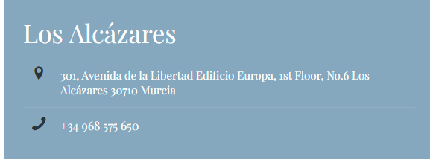
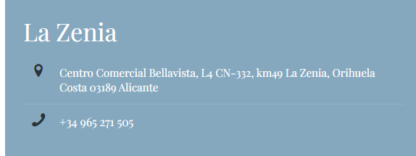
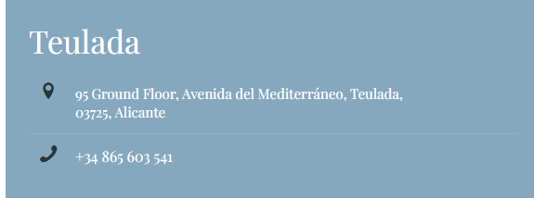
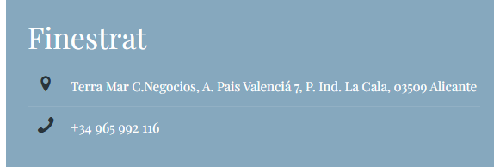
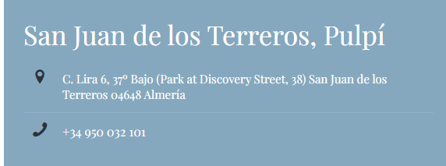

Your investment deserves peace of mind.

We’ll take care of the rest.



Disclaimer
This guide provides a general overview of the Spanish tax system to help you better understand the legal and financial aspects of buying or owning property in Spain. However, every case is different, and this information should not be considered legal or tax advice. For guidance tailored to your personal situation, we strongly recommend consulting a qualified advisor.
You can also visit the official Spanish Tax Agency (Agencia Tributaria) for up-to-date regulations. And if you’re looking for expert support, the multilingual team at Fuster & Associates is here to assist you every step of the way.

